S.No | Inputs |  |  |  | Outcomes
 | Laser Power  P_{LZ} | Scanning Speed  S_{SP} | Number of passes  P_{C} | Laser Frequency  F_{LZ} | Surface waviness  S_{W} | Material Vaporization rate  MV_{R} | Heat affected zone  HA_{Z}
 | W | (mm/min) | no unit | (kHz) | (µm) | (mm³/sec) | (µm)
1 | 8.5 | 280 | 24 | 48 | 6.07 | 100.71 | 90.05
2 | 6.5 | 360 | 12 | 18 | 4.01 | 74.77 | 71.88
3 | 10.5 | 200 | 36 | 18 | 6.75 | 119.88 | 102.71
4 | 6.5 | 360 | 36 | 58 | 5.1 | 79.11 | 85.07
5 | 6.5 | 200 | 12 | 58 | 6.01 | 93.27 | 89.82
6 | 8.5 | 280 | 18 | 38 | 5.9 | 99.84 | 88.42
7 | 10.5 | 200 | 12 | 18 | 6.05 | 117.2 | 89.89
8 | 8.5 | 320 | 24 | 38 | 5.66 | 95.14 | 88.12
9 | 6.5 | 360 | 12 | 58 | 4.13 | 66.76 | 74.46
10 | 10.5 | 360 | 36 | 58 | 5.23 | 82.97 | 85.36
11 | 8.5 | 280 | 30 | 38 | 6.26 | 110.85 | 93.12
12 | 10.5 | 200 | 36 | 58 | 7.32 | 115.82 | 108.08
13 | 10.5 | 360 | 36 | 18 | 4.9 | 90.99 | 82.88
14 | 6.5 | 200 | 12 | 18 | 5.6 | 102.68 | 86.30
15 | 8.5 | 240 | 24 | 38 | 6.44 | 115.36 | 93.28
16 | 7.5 | 280 | 24 | 38 | 6.02 | 102.48 | 89.51
17 | 10.5 | 360 | 12 | 18 | 4.33 | 86.1 | 75.64
18 | 8.5 | 280 | 24 | 28 | 5.94 | 107.2 | 89.40
19 | 9.5 | 280 | 24 | 38 | 6.21 | 108.79 | 90.81
20 | 6.5 | 200 | 36 | 58 | 7.1 | 122.52 | 106.40
21 | 6.5 | 360 | 36 | 18 | 4.69 | 87.58 | 78.76
22 | 6.5 | 200 | 36 | 18 | 6.63 | 114.14 | 94.76
23 | 10.5 | 200 | 12 | 58 | 6.43 | 107 | 94.59
24 | 10.5 | 360 | 12 | 58 | 4.69 | 78.57 | 81.59
Output | SVR  Hyper  parameter | SVR  R² | Elasticnet  Hyper  parameter | EN R² | XGB Hyper  parameter | XGB  R² | NN Hyper  parameter | NN  R²
Surface Roughness | {'C': 10, 'kernel': 'rbf', 'gamma': 'scale'} | 0.989 | {'alpha': 0.1, 'l1_ratio': 0.5} | 0.898 | {n_estimators=100, max_depth=5, learning_rate=0.05} | 0.999 | {'hidden_layer_sizes': architecture=(6,4,3), alpha=0.001, learning_rate=0.0} | 0.979
Material Melting Rate | {'C': 10, 'kernel': 'rbf', 'gamma': 'scale'} | 0.916 | {'alpha': 0.1, 'l1_ratio': 0.5} | 0.865 | {'n_estimators':100,  'max_depth':5,  'learning_rate':0.05,  'subsample':0.8} | 0.997 | {'hidden_layer_sizes:'  architecture=(8,5,4), alpha=0.001, learning_rate=0.01} | 0.887
HAZ | {'C': 10, 'kernel': 'rbf', 'gamma': 'scale'} | 0.916 | {'alpha': 0.1, 'l1_ratio': 0.5} | 0.940 | {'n_estimators':100,  'max_depth':5  ,'learning_rate':0.05,  'subsample':0.8} | 0.998 | {'hidden_layer_sizes': architecture=(6,3,2), alpha=0.001, learning_rate=0.01} | 0.744

Hyperparameter
Ensemble Performance Summary
Ensemble Performance Metrices
Target | RMSE | MAE | R²
Surface Roughness | 0.0942 | 0.0837 | 0.9889
MMR | 1.8572 | 1.5424 | 0.9852
Heat Affected Zone | 0.8444 | 0.6748 | 0.9909

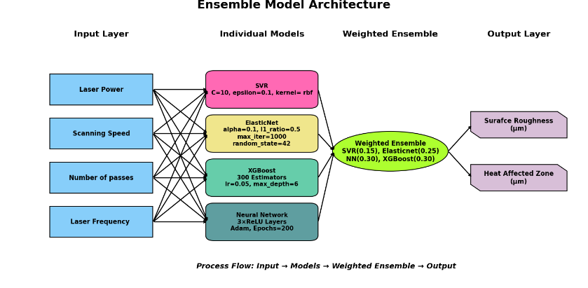
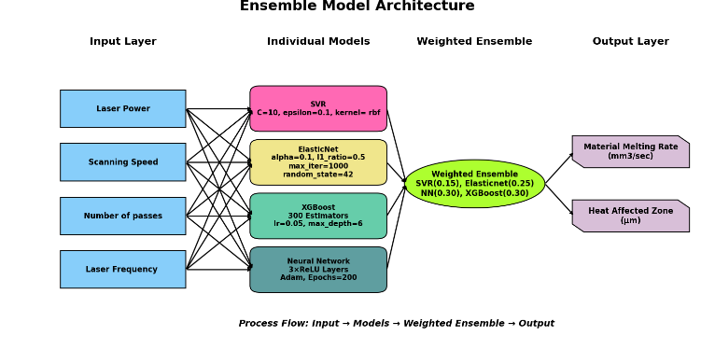

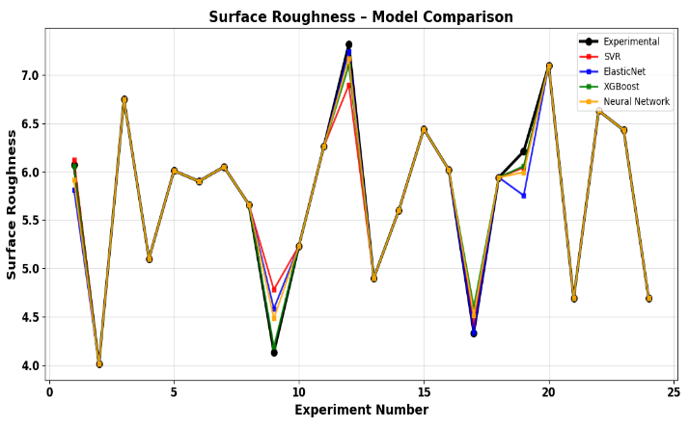
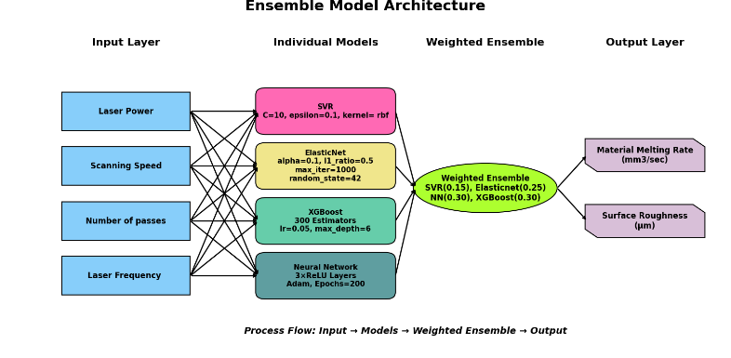

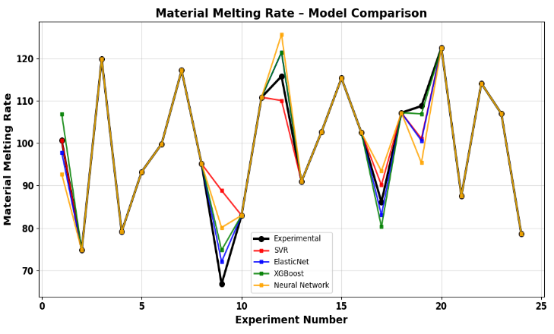
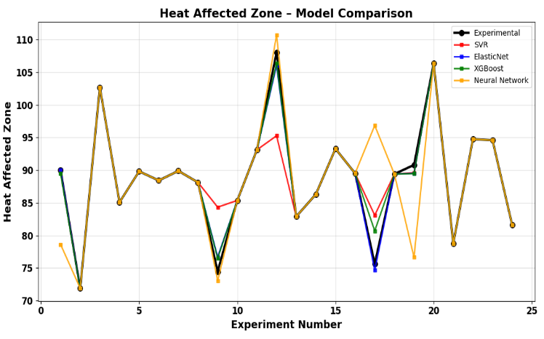
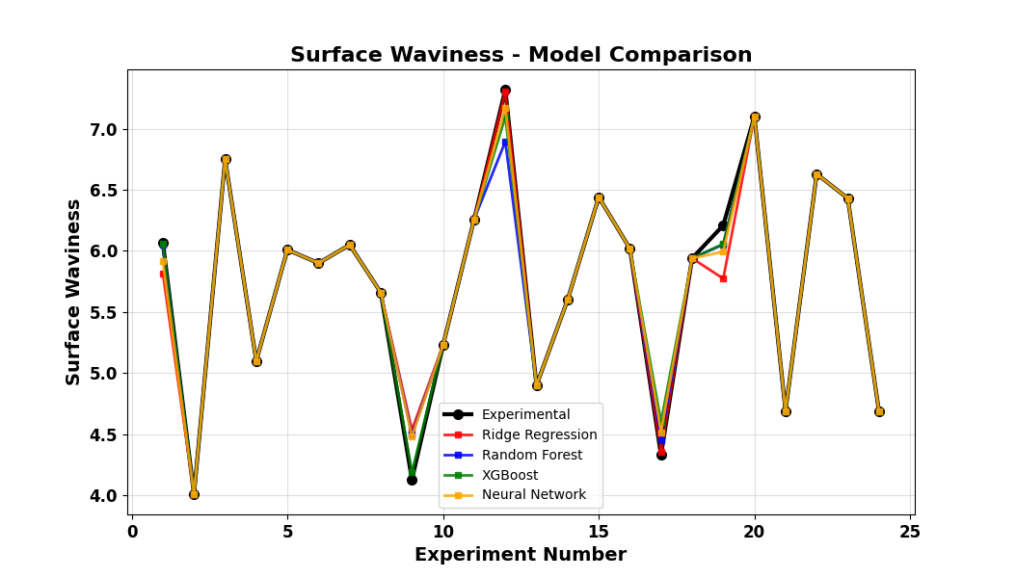
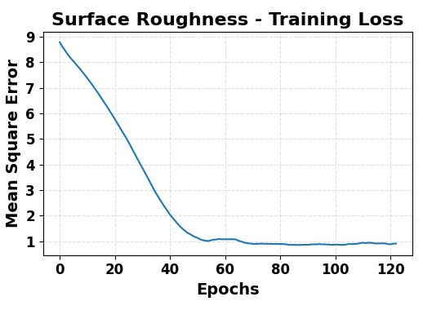
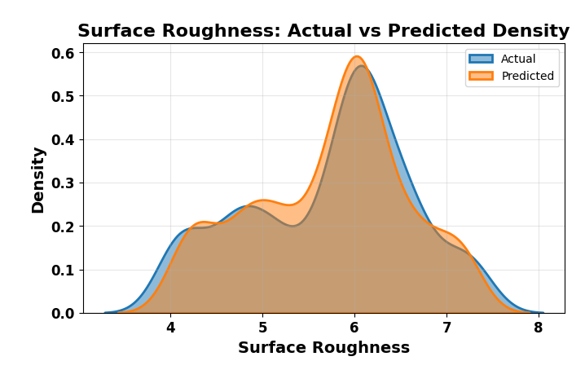
SURFACE ROUGHNESS

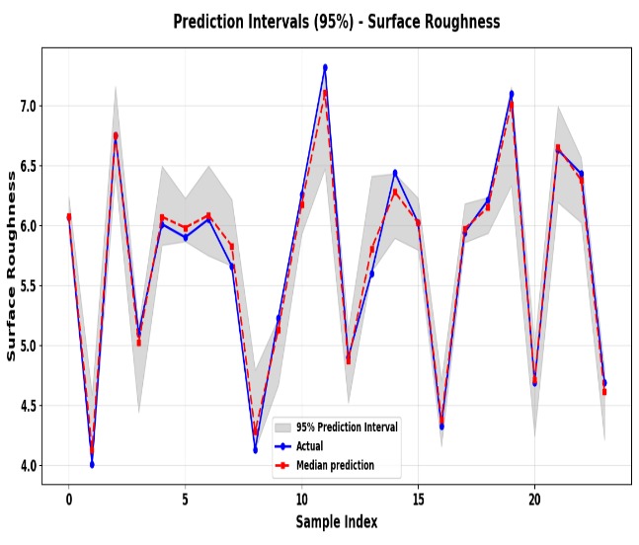
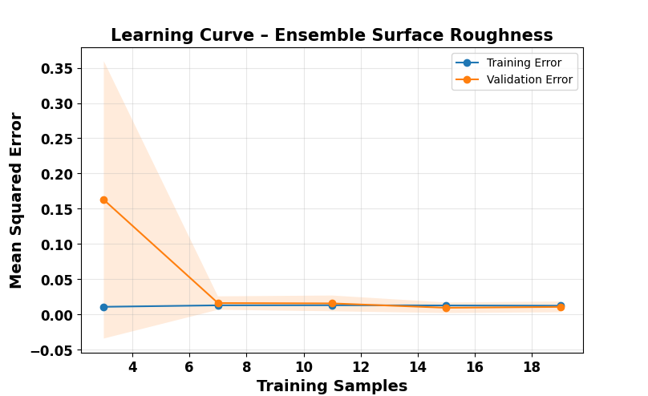

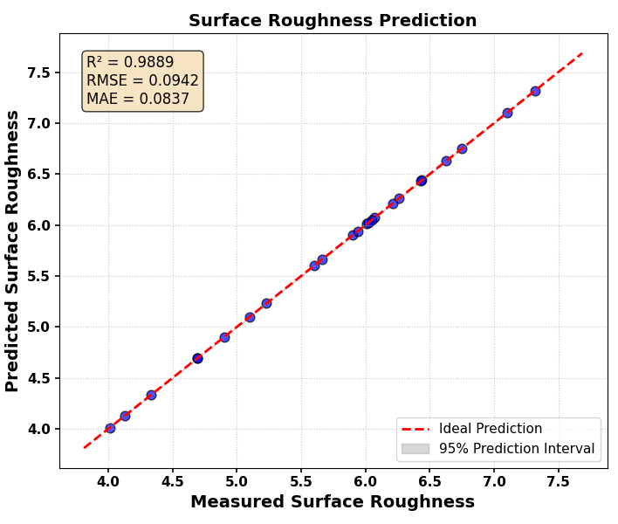
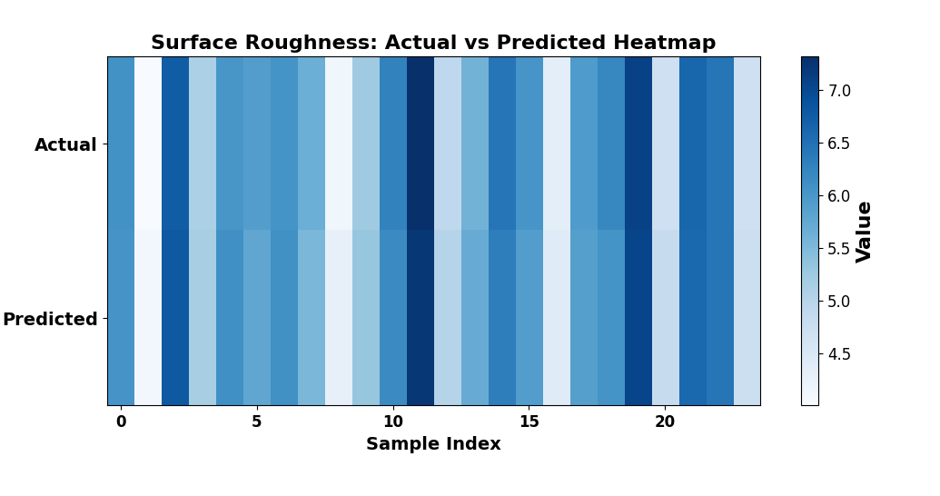

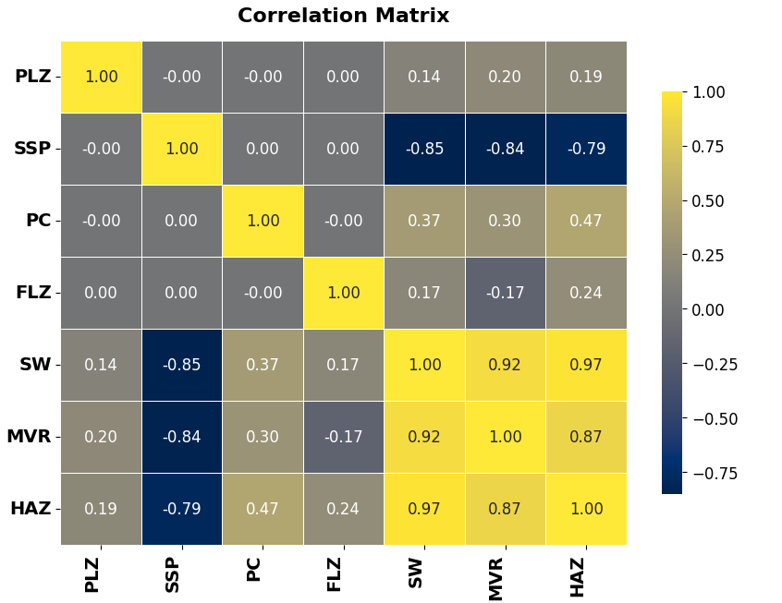
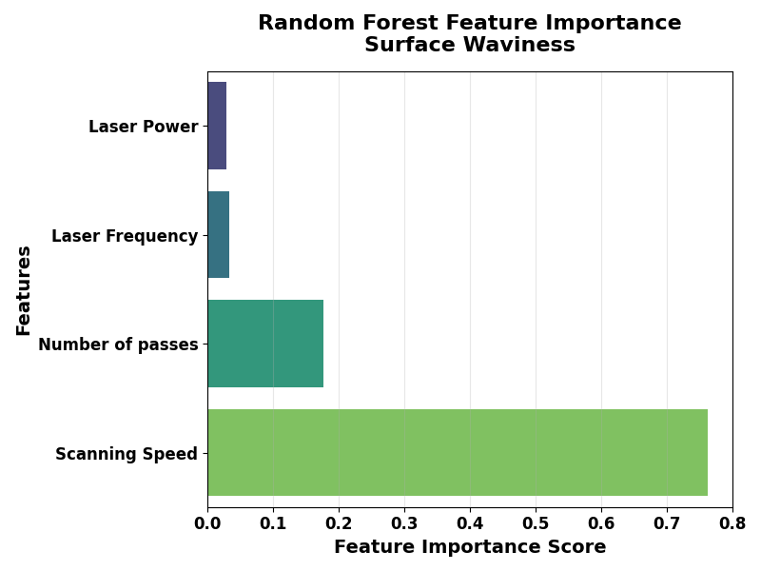
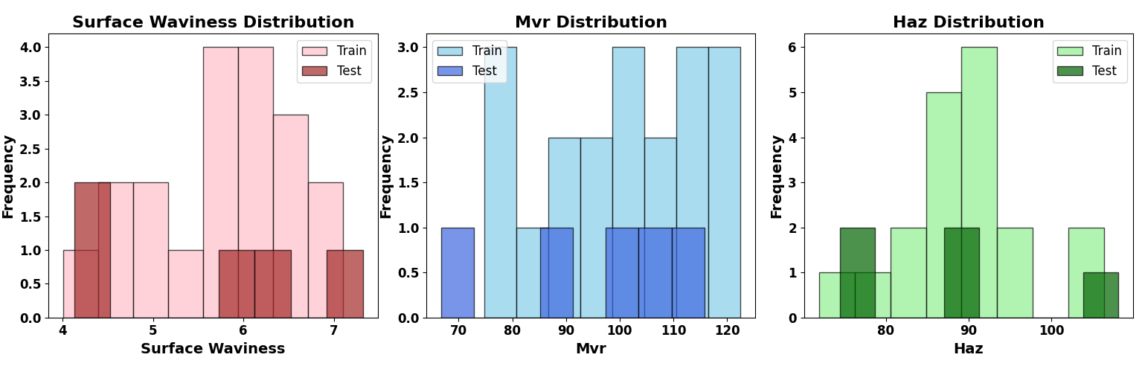
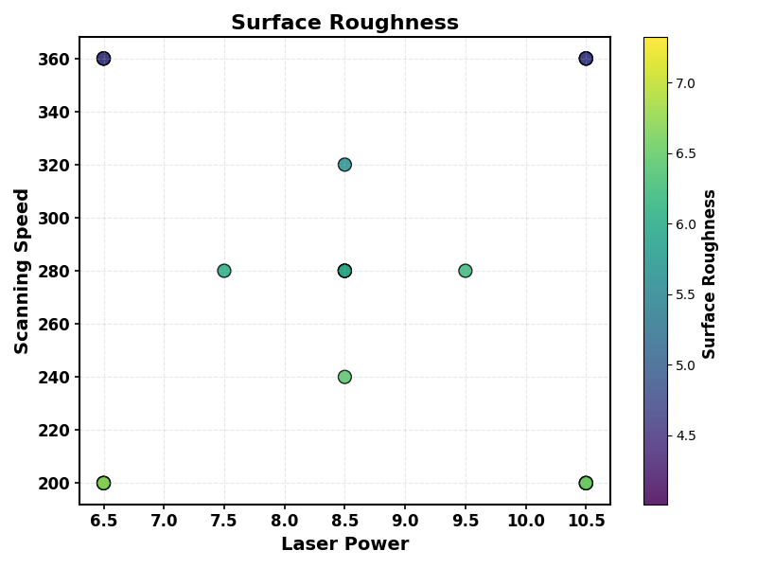
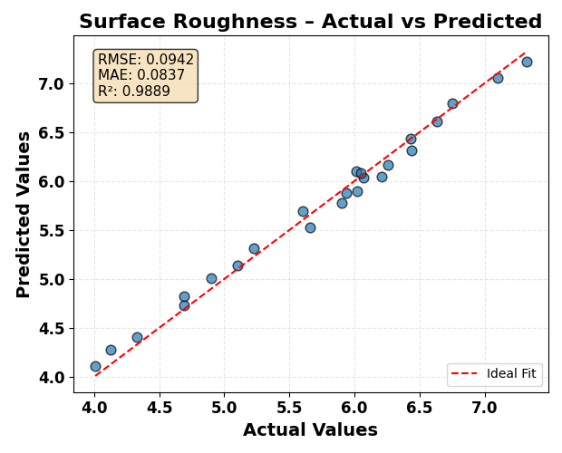

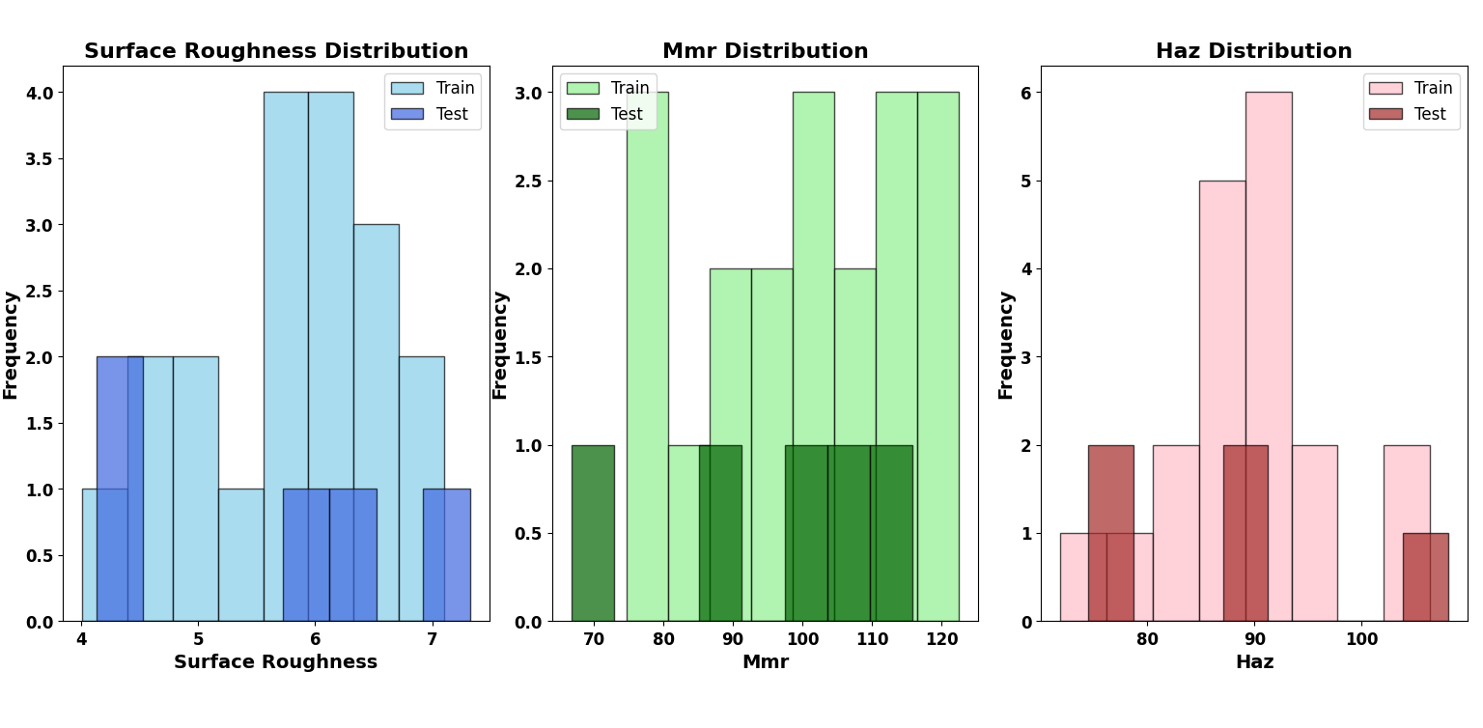
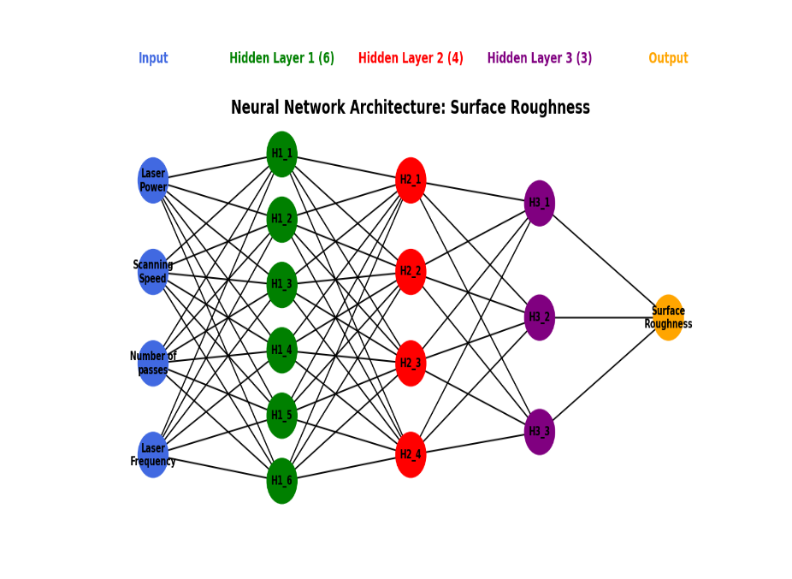

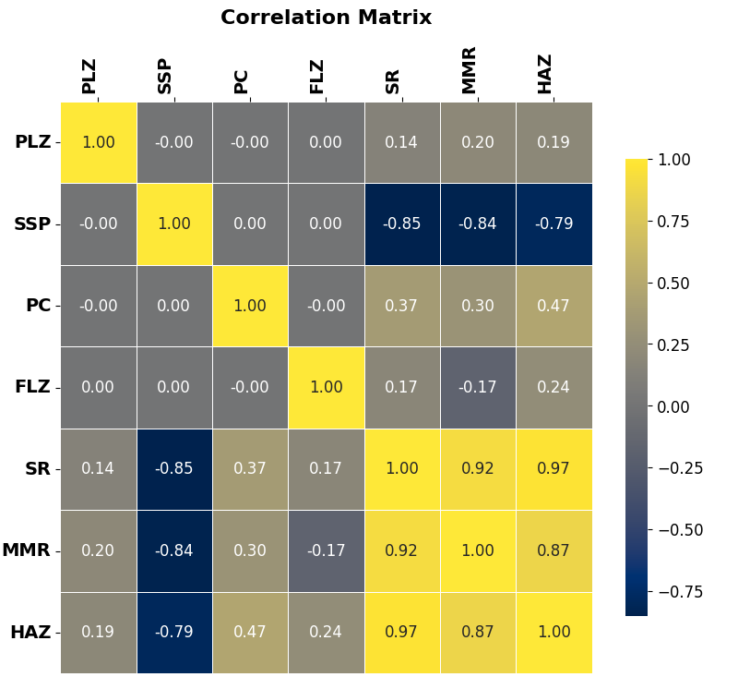
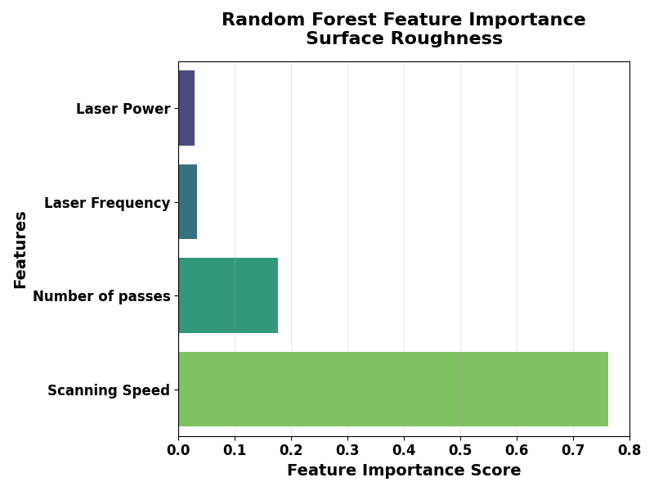

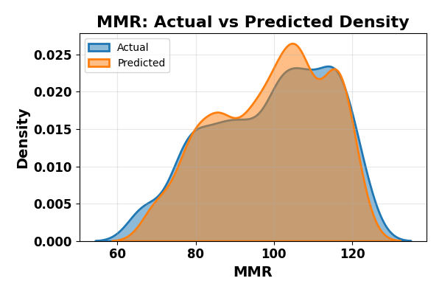
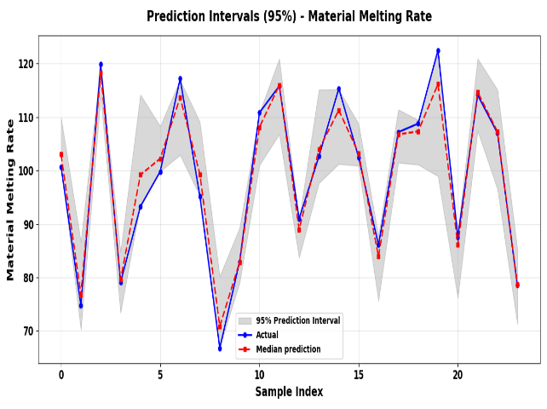
MMR

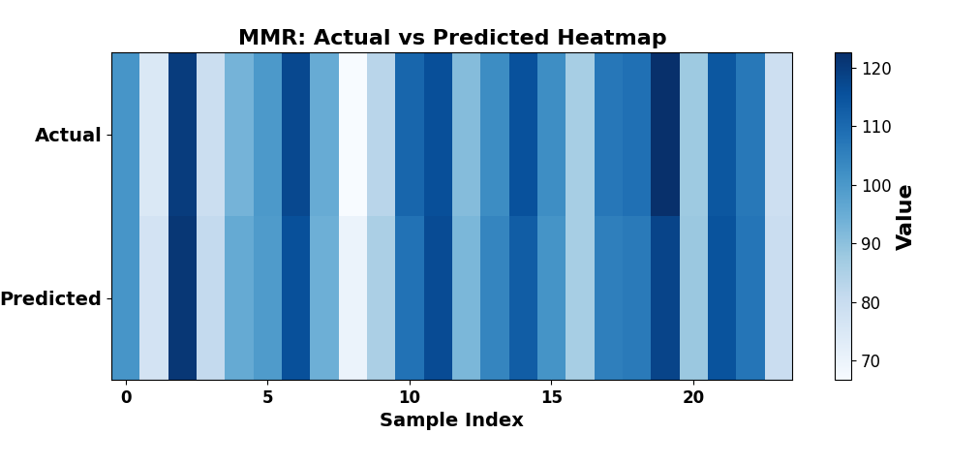
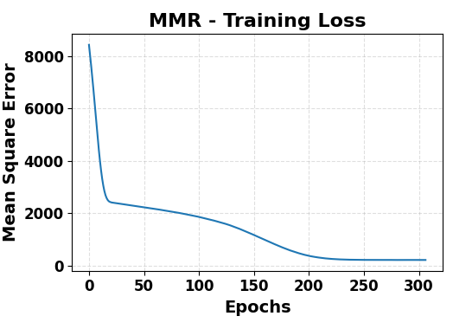

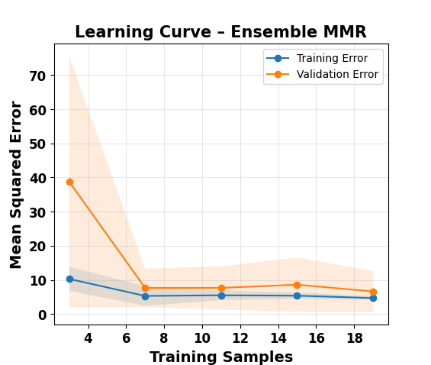
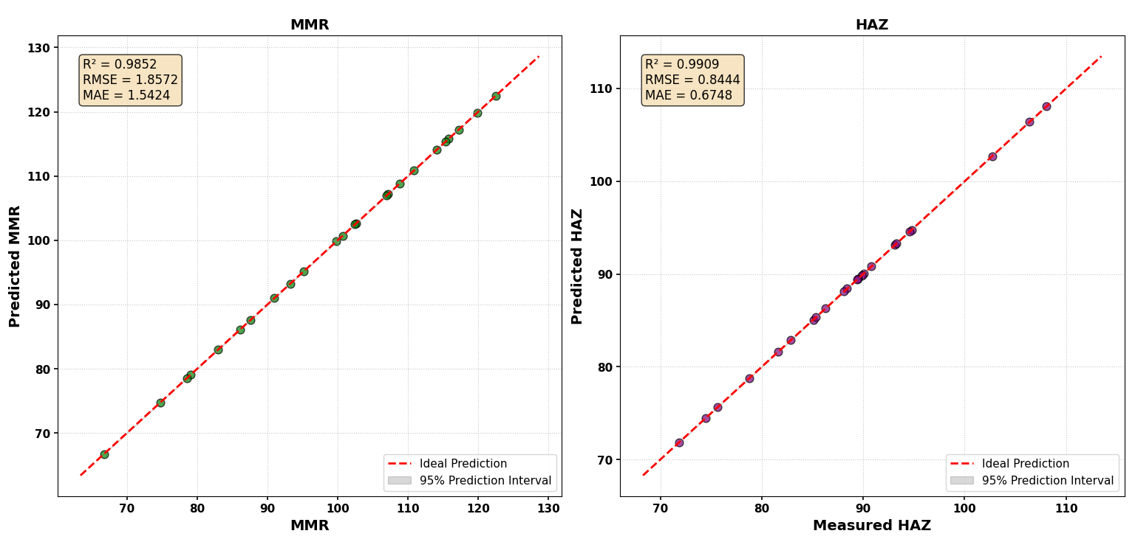

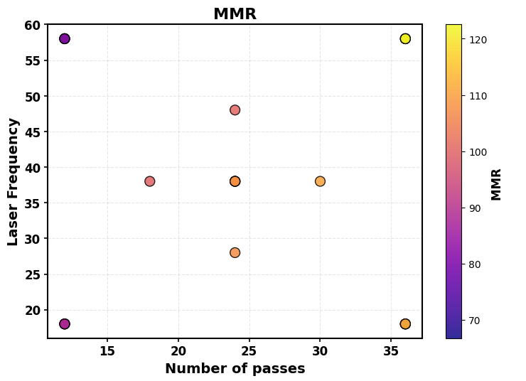
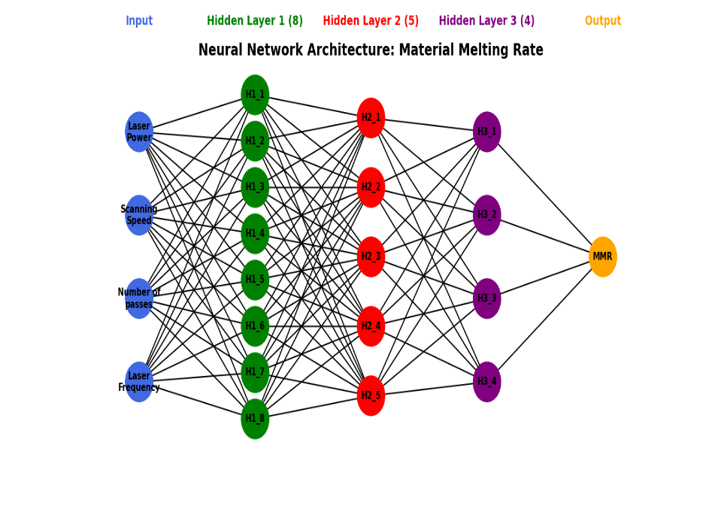
v

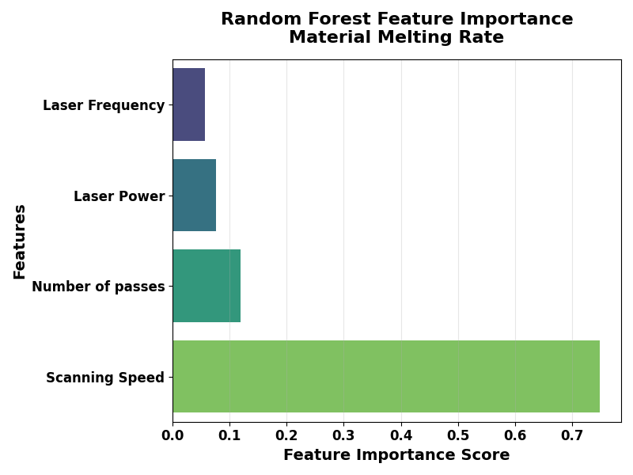

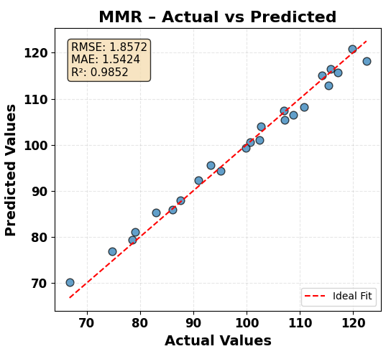
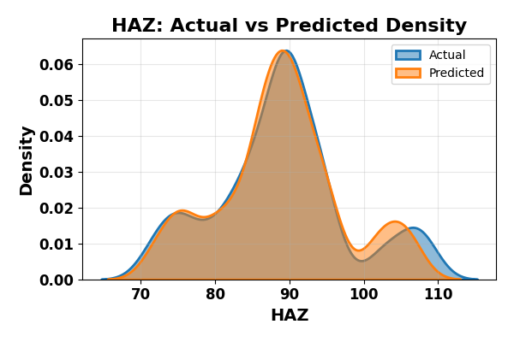
HAZ
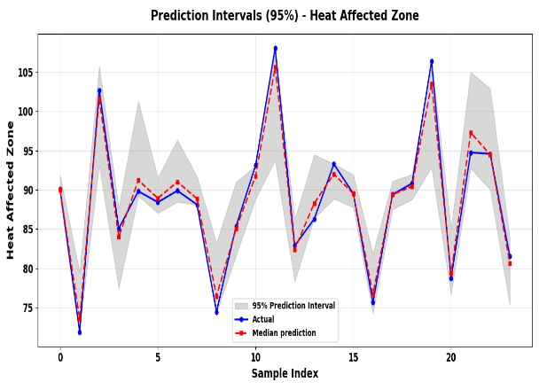
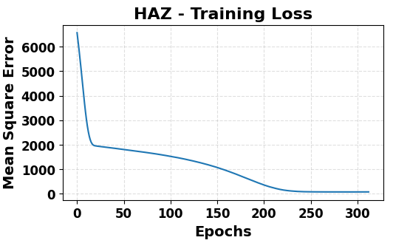

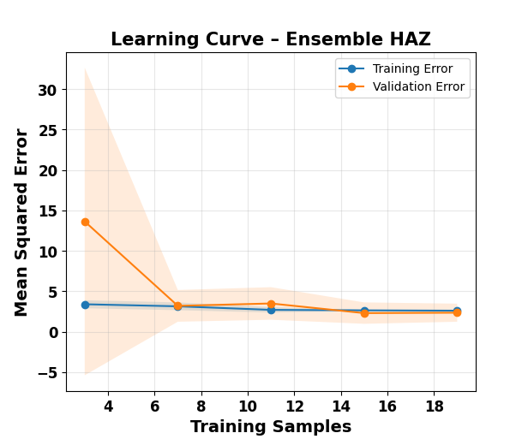


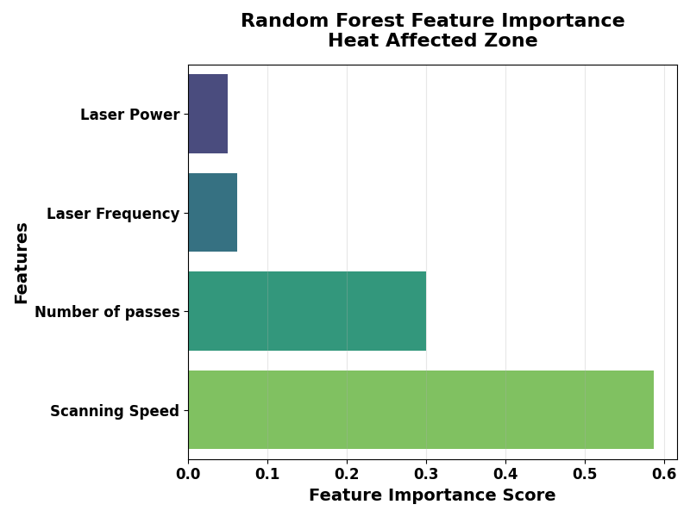
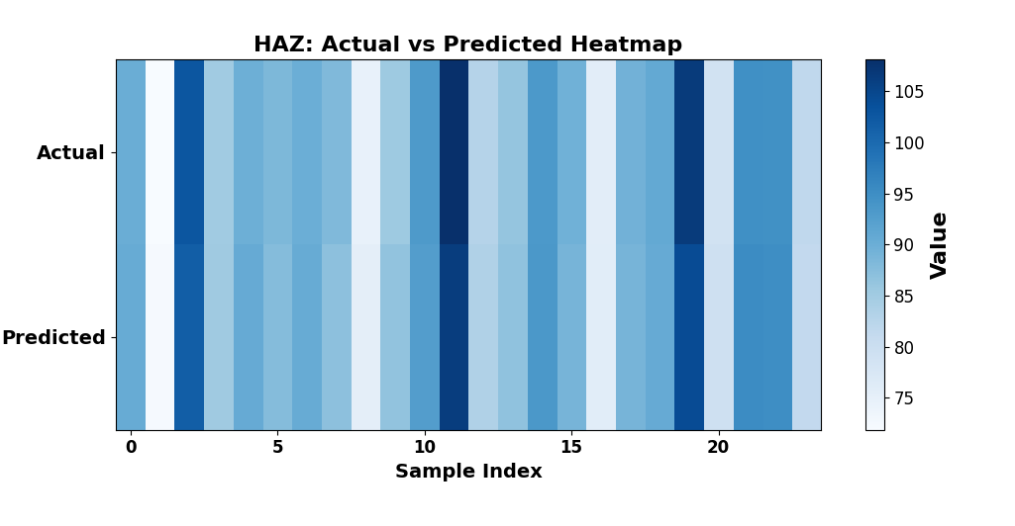
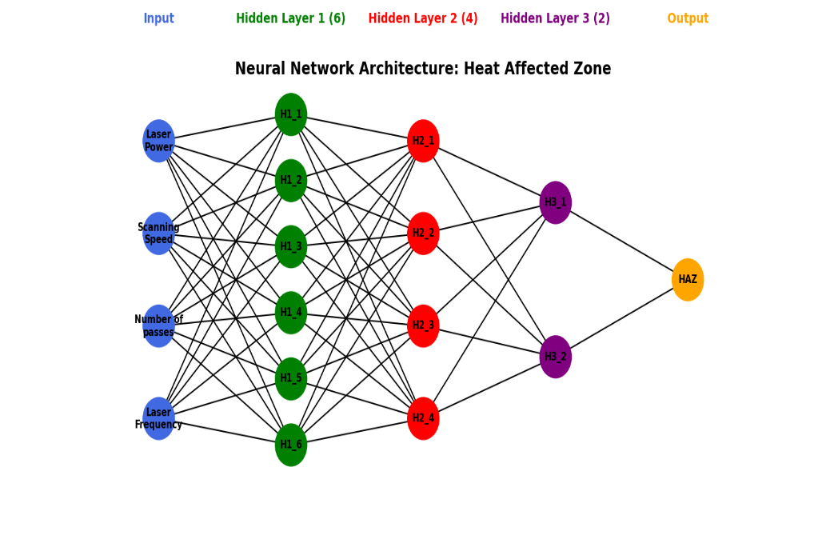
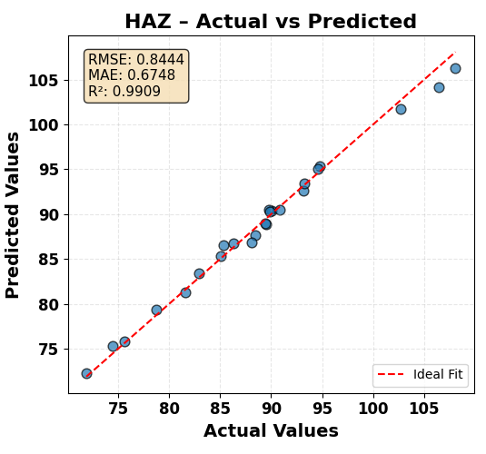
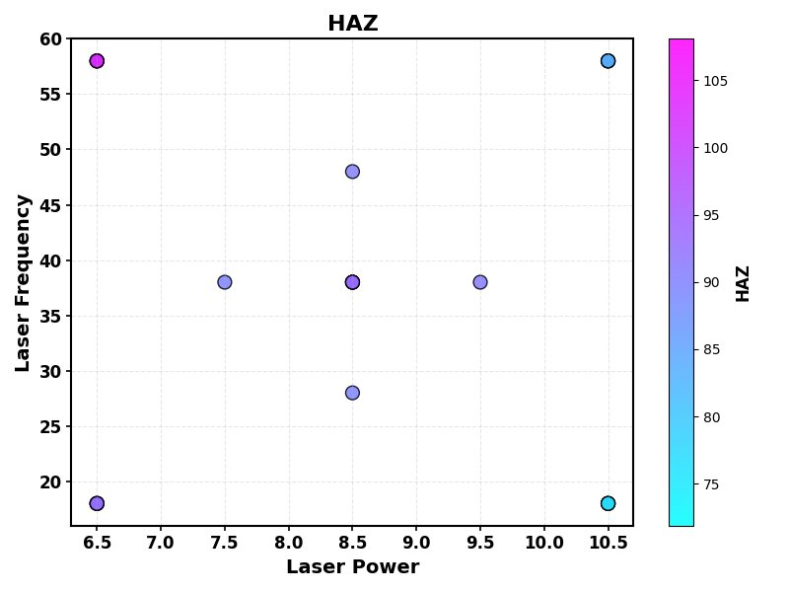
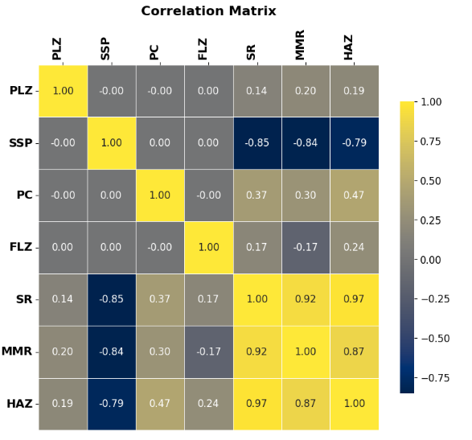

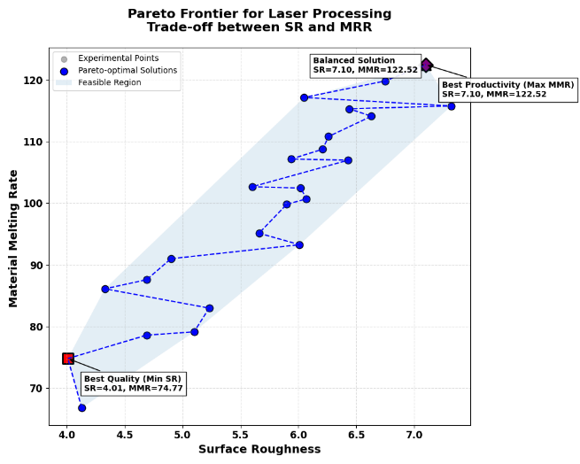
Table 3: Optimal Laser Process Parameter
Parameter | Min SR | Min HAZ | Balanced
Laser Power | 6.50 | 6.50 | 6.50
Scanning Speed | 360.00 | 360.00 | 360.00
Number of passes | 12.00 | 12.00 | 12.00
Laser Frequency | 18.00 | 18.00 | 18.00
Surface Roughness | 4.108 | 4.108 | 4.108
HAZ | 72.297 | 72.297 | 72.297
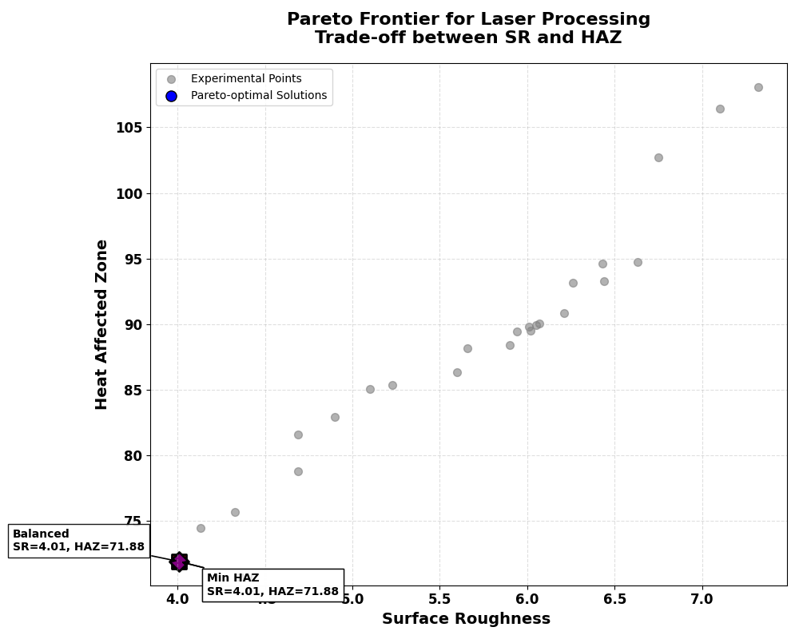

Table 3: Optimal Laser Process Parameter
Parameter | Min HAZ | Max MMR | Balanced
Laser Power | 6.50 | 10.50 | 10.50
Scanning Speed | 360.00 | 200.00 | 200.00
Number of passes | 12.00 | 36.00 | 12.00
Laser Frequency | 18.00 | 58.00 | 18.00
Heat Affected Zone | 72.297 | 101.676 | 90.311
MMR | 76.813 | 120.794 | 115.681
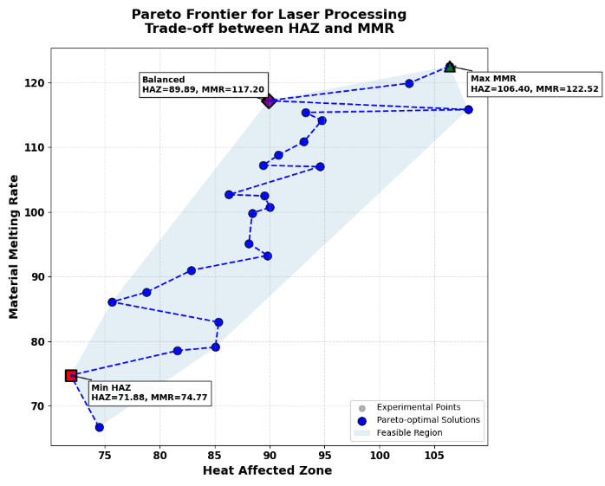
Table 3: Optimal Laser Process Parameter
Parameter | Min SR | Max MMR | Balanced
Laser Power | 6.50 | 10.50 | 10.50
Scanning Speed | 360.00 | 200.00 | 200.00
Number of passes | 12.00 | 36.00 | 36.00
Laser Frequency | 18.00 | 18.00 | 18.00
Surface Roughness | 4.108 | 6.794 | 6.794
MMR | 76.813 | 120.794 | 120.794

